|  |  |
| --- | --- |
| **Front End Development**  Diploma in IT, ISF  2018/19 Semester 2 | Week **1** |
| 4 Hours |
| **Creating a Web Page using Structural HTML Elements** | |

**Activities**

**Task 1**

* Read Part I – Getting Started (Chapters 1-3) from the textbook.

|  |
| --- |
| **Note: This is a recommended activity. You may opt to skip to Task 2 and 3 if you have good understanding of how the web works.** |

**Task 2**

* Watch the following video clip from Lynda.com.
  + HTML overview/review

<https://www.lynda.com/CSS-tutorials/HTML-overviewreview/569190/601571-4.html>

* You need to sign in with your email address to view the full video.
* Download the following files from MEL :-
  + Main.html
  + HTML5Badge.png
  + HTML5Badge.ico
* Complete Part 1 of the Week 1 Practical.

**Task 3**

* Complete Part 2 of the Week 1 Practical.
* Submit the completed practical files (Part 2 only) to your folder in //ictspace/FED by Sunday 2359hrs of Week 1.

If you have any questions please contact your tutor via Microsoft Teams.

**Part 1: Hello World**

1. Open the Main.html for editing in Visual Studio.
   * Right click on Main.html and select open with Microsoft Visual Studio 2017
2. Modify the file as follows:
   * Change the author to your name.
   * Change the description to “My first HTML document”.
   * Change the title to “Hello World”.
   * Change the email address to yours.
   * In the body, place the text “Hello World!” within <h1> tags.
   * In the next line type “This is my first HTML page.” without the quotes.
3. Save the file as **HelloWorld** and view in browser.
4. Experiment with different colours for viewing on screen and printing.

**Challenge!**

How can you display both the lines of text in two different colours as below?

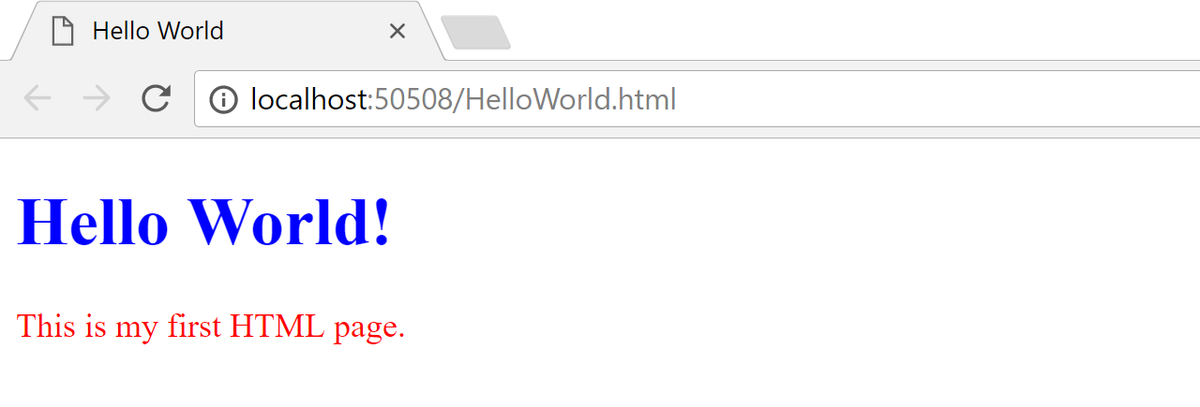

**Part 2: Creating a web page from scratch**

1. Launch Visual Studio.
2. Create a new project and name it as **Week1Practical**.
   * Click File 🡪 New 🡪 Project

The default location is C:\Users\**Your Name**\source\repos. You may change the location to a folder of your choice.

* + Select Other Project Types 🡪 Visual Studio Solutions as shown below.
  + Enter Name as Week1Practical

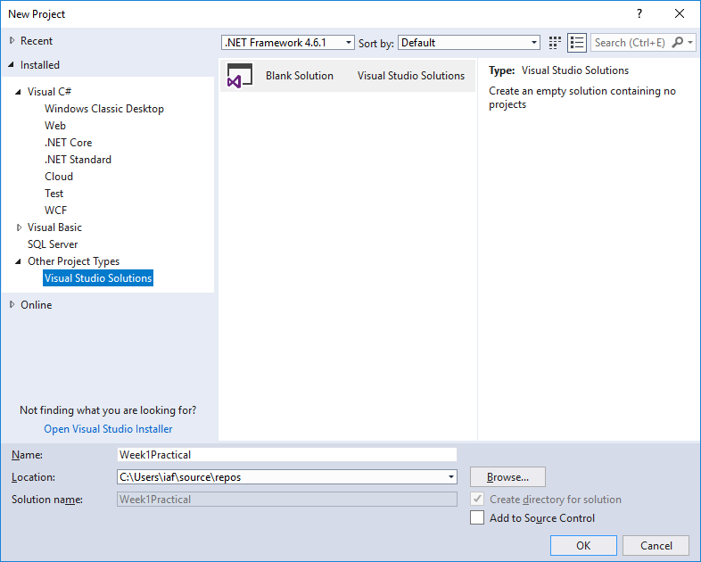

* + Click OK to continue.

1. Click Solutions and Folders button in the Solutions Explorer and select Week1Practical as shown below.

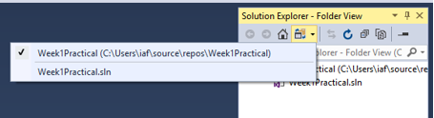

1. Create a new folder named **images** within the project and add the image files HTML5Badge.png and HTML5Badge.ico into this folder.

* Right click Week1Practical in the solution Explorer.
* Select Add 🡪 New Folder.
* Name the folder as images.
* Right click anywhere in the Solution Explorer and select Open Folder in File Explorer.
* Copy and paste the two image files to this folder.

1. Add a new HTML page and name it as **index.html**.

It is common practice to name the first page of a website as [index.html](https://www.thoughtco.com/index-html-page-3466505). Click the link to read about “Understanding the Index.html Page on a Website”.

* Right click the ‘Week1Practical’ in the solution Explorer.
* Select Add 🡪 New Item.
* Select HTML Page and click Open.
* Name the file as **index.html**.
* Use all lower case.

1. Enter the meta tags for author and description.
2. Type the title as “Week 1 Practical”.
3. Type the following link tag in the <head> element.

<link rel="icon" type="image/x-icon" href="images/HTMLBadge.ico" />

This adds the favicon that is displayed next to the page’s title on the browser.

1. In the body enter a <header> element and type the following within it.

<h1>HTML5</h1>

<figure>

<img src="images/HTML5Badge.png" alt="HTML5 Badge" title="HTML5 Badge"/>

<figcaption>Official HTML5 Logo</figcaption>

</figure>

1. Save the file and view in browser.
   * Ensure the cursor is in the workspace
   * Click File 🡪 View in Browser.

Use Google Chrome as the default browser.

You can set the default browser as follows:

* File 🡪 Browse With…
* Select Google Chrome
* Click **Set as Default** button.

1. Next enter a <section> element and type the HTML code to create the following lists within the section. Use <h2> for the headings.

**Textbook Topics**

* HTML
* CSS
* JavaScript

**HTML Chapters**

1. Structural Elements
2. Text Elements
3. Table Elements
4. Embedded Elements
5. Form Elements
6. Type the following code below the lists.

<h3>Download the book from the link below.</h3>

<iframe src="https://ebookcentral-proquest-com.libproxy.np.edu.sg/lib/np/detail.action?docID=5412749" width="100%" height="400">

<p>Your browser does not support iframes</p>

</iframe>

This creates an inline frame to embed the website with specified dimensions. The statement Your browser does not support iframes will be displayed if the web browser does not support iframes.

Notice that you can scroll the web page within the inline frame.

1. Save the file and view in browser to see how it looks now.
2. Create another <section> element and write the code to display the following:

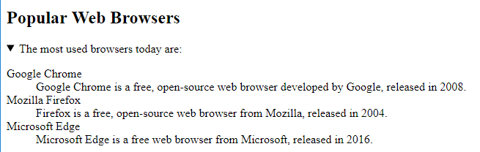

* Use <h2> for the heading.
* Create a collapsible section using description list <dl> to display the information about the browsers.

When collapsed it should look as shown below.

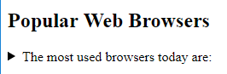

1. Next create a <footer> element and within it an <address> element to display the following.

*Developed by*[*Your name*](mailto:your%20email%20address)

* Type your name in place of [*Your name*](mailto:your%20email%20address).
* Use mailto: to link to your email address when your name is clicked.

1. Save the file and view in browser to see how it looks now.
2. Copy the entire **Week1Practical** folder to your folder in \\ictspace\FED.

**Challenge**

How would you add a thick solid black border around the list of web browsers as shown below?

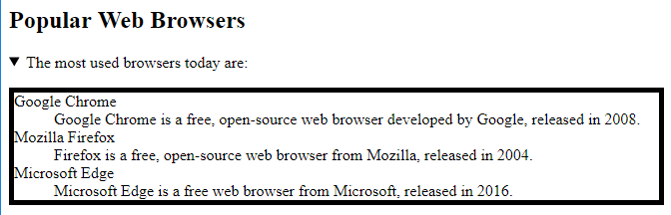

== End of Worksheet ==